Embark – Willamette Red Sweater Project and Northern Tanzania Safari

Arusha - Red Sweater Project - Tarangire National Park - Serengeti - Ngorongoro Cratrer
8 Days / 7 Nights
Date of Issue: 22 April 2016

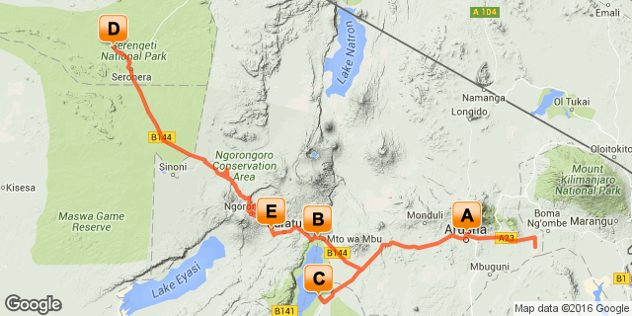

DAY 1: ARRIVAL AND ARUSHA

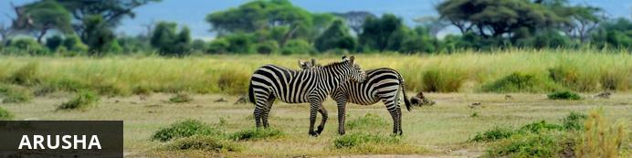
Arusha is the safari capital of Tanzania located at the foot of Mt. Meru, close to Mount Kilimanjaro, the Manyara, Tarangire and Ngorongoro National Parks. From there it’s only a short trip to the Serengeti. Just to the north, on the slopes of Mt. Meru is the Arusha National Park. Built by the Germans as a centre of colonial administration because of the temperate climate, Arusha is a good spot to take a day or two off from your safari.

Day Notes
Upon arrival and clearing immigration and customs, you will be warmly greeted by our staff and taken to your lodge for the night to rest and relax from your long flight.

Activities
Transfer to lodge

Overnight: Ilboru Safari Lodge
Nestled on the lower slopes of the majestic Mt Meru, the Ilboru Safari Lodge is popular with mountain climbers and safari travelers in northern Tanzania. Ideally located between the northern safari circuit and Mt Kilimanjaro, the beautiful Swahili sanctuary is set on a five acre plot, tucked away beneath ancient trees on the outskirts of Arusha town. The lodge features thirty eight guest rooms, comprising of single, double, twin, triple and family rooms. Four rooms are in the main building, close to the pool and other facilities, each with a balcony overlooking the garden. The rest of the rooms are double cottages situated throughout the lushly landscaped grounds.
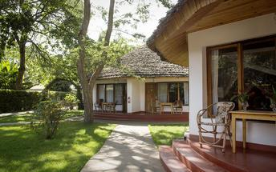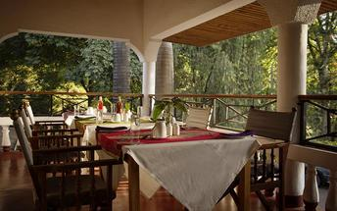

Included
Dinner and Breakfast
Transfer from Airport to Lodge

DAY 2-5: RED SWEATER PROJECT

Day Notes

After breakfast, you will be transferred out to Mto wa Mbu/Mungere Village just outside of Lake Manyara National Park where the Red Sweater Project is located. You will spend the next two days at the Project.

Activities
Spend the day at the Red Sweater Project; visit a Maasai boma (traditional Maasai ‘village’), trek through a rural village or hike to a spectacular secluded waterfall along the Great Rift Valley.

Overnight: Fig Tree Lodge, Mto Wa Mbu

DAY 6: TARANGIRE NATIONAL PARK

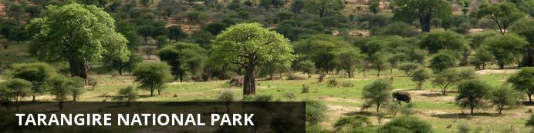
After the Serengeti, Tarangire has the greatest concentration of wildlife in Tanzania and in the dry season the Tarangire River is a magnet for thirsty wildlife. Large herds of elephants and migratory wildebeest, zebra, buffalo, impala, gazelle, hartebeest and eland gather and not surprisingly the predators follow. This is also the one place in Tanzania where dry-country antelope such as oryx and gerenuk are regularly spotted. Tarangire is also known for its spectacular baobab trees, and its breathtaking views of the Masaai Steppe and the mountains to the south.
Located just a few hours drive from the town of Arusha, Tarangire is a popular stop for safaris travelling through the northern circuit on their way to Ngorongoro and the Serengeti. The park extends into two game controlled areas and the wildlife are allowed to move freely throughout.

Day Notes
After morning breakfast, you will say your goodbyes at the project and head to Tarangire National Park. Tarangire is the sixth largest park in Tanzania. With baobab and acacia trees, much like the Serengeti, Tarangire is home to legions of elephants, which inhabit this park in large herds. In the park you also find other game such as rhino, buffalo, eland, warthog, the fringe-eared oryx, lesser and greater kudu, gerenuk and a large number of impala. The rains scatter the seasonal visitors over a 20,000 square kilometre(about 12,500 sq miles) range until they exhaust the green plains and the river calls once more. But Tarangire mobs of elephant are easily encountered,wet or dry. The swamps, tinged green year round, are the focus for 50 bird varieties, the most breeding species in one habitat anywhere in the world. On drier ground you find Koori bustard, the heaviest flying bird; the stocking sighed ostrich, the world largest bird; and ground hornbills that bluster like turkeys. Tarangire pythons climb trees, as do this lions and leopards, lounging in the branches where the fruit of the sausage tree disguises the twitch of a tail.

Activities
Game dive in Tarangire National Park

Overnight: Maramboi Tented Camp

This is a unique opportunity to experience and explore the Tarangire and Manyara ecosystem.

Maramboi Tented Camp offers permanent camp facilities and endless vistas of rolling golden grasslands and palm lined desert between Tarangire and Manyara Lake. A visit to the area is essential for anyone interested in evolution and the origins of Mankind and an explanation of the Rift Valley and Africa’s big picture. It is a complete semi desert experience focusing on safari walks and game drives.
40 spacious tents built on ample wooden decks, among them there are 26 standard rooms, 10 suites and 2 units with 2 rooms interconnected, ideal for families with children. They all have en suite facilities and private veranda with 24 hours 220V electric lighting.
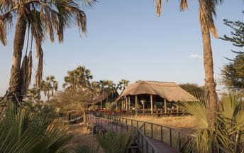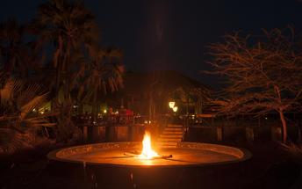

Included
Breakfast, Lunch and Dinner, Specified Activities

DAY 7-8: CENTRAL SERENGETI

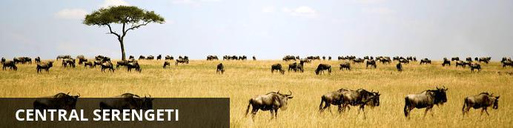
The Serengeti together with Kenya’s Masai Mara Game Park form Africa’s most famous wildlife park. The image of acacia trees on an endless grass plain epitomises Africa for many, and then add a Masai warrior and some cattle to the picture and the conversation need go no further.
The annual wildebeest migration through the Serengeti and the Masai Mara is the largest mass movement of land mammals on the planet – with more than a million animals following the rains. But that is not where the game viewing ends; large prides of lions, elephants and giraffes in grasslands, gazelles and eland to mention but a few. Aside from traditional vehicle safaris, hot-air ballooning over the Serengeti plains has become almost essential and you can even do a horseback safari.

Day Notes
From Tarangire National Park, we will travel to the legendary Serengeti National Park. This will be about a four to five hour drive, driving on the Rim of the Ngorongoro Crater. More than 6 million hooves pound the legendary plains of the Serengeti. Every year, triggered by the rains, more than a million wildebeest, 200,000 zebra and 300,000 Thomson's gazelle gather to undertake the long trek to new grazing lands. Tanzania's first and most famous park, the Serengeti is renowned for its wealth of leopard and lion. The vast reaches of the park help the black rhino to fight extinction and provide a protected breeding ground for the vulnerable cheetah. Today you will witness predator vs. prey and the fundamental independence of the Serengeti's abundant species, from more than 500 varieties of bird to 100 types of dung beetle.

Spend next two days exploring the world famous Serengeti.

Activities
Drive to Serengeti via Olduvai Gorge

Olduvai Gorge
Olduvai Gorge is a paleoanthropological site of major significance, where an old river has carved away the rock to expose layer upon layer of volcanic soil. This is where Dr Louis and Mary Leakey found the remains of hominids "Nutcracker Man", "Tool Making Man" and "Lucy", discoveries that have helped to fill some of the missing links in the chain of human evolution and added more evidence to the theory of modern man’s emergence in Africa.
The "Cradle of Mankind" now has a visitor centre where you may hear a short lecture on the work of the Leakey’s and their successors and a small museum where you may see some of their finds, including a giant giraffe - it is hard to believe that they were once even taller!

Overnight: Kati Kati Mobile Camp

Serengeti Kati Kati is a mobile tented camp located in Central Serengeti, strategically located to cover the vast Serengeti Plains. The camp offers comfortable accommodation and a unique opportunity to enjoy a real safari camp experience, just a two-hour scenic drive from Olduvai Gorge Museum and Grumeti River.

Accommodation comprises 20 tents with en-suite facilities, with a cozy mess tent located in the centre of the camp where meals are served. The campfire is ready every evening for appetizers and snacks before dinner.

Serengeti National Park is one of the largest wildlife sanctuaries on the planet and the largest National Park in Tanzania, covering an extension of 15,000 square kilometers. Its landscapes depict the mythical image of an Africa of large spaces, profound blue skies dotted with clouds, cool sunrises and fire-red sunsets.
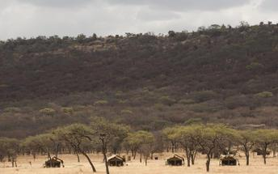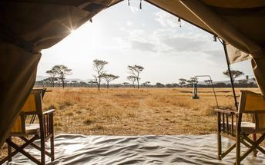

Included
Breakfast, Lunch and Dinner, Specified Activities

DAY 9: SERENGETI TO NGORONGORO REGION

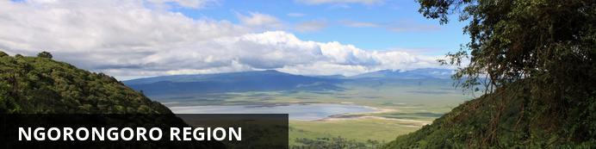

Situated in the shadow of the Ngorongoro Crater the area around Karatu is perfect for exploring two of Tanzania’s gems, the Crater and Lake Manyara National Park.

Day Notes
Begin with an early morning departure through the Serengeti and head to Ngorongoro Crater. Leaving the Serengeti behind we drive past Olduvai Gorge,which was made famous by the Leakey's in their quest for the origin of mankind. Fragments of a skull were unearthed in 1959 dated at 1.8 million years old and later in 1979 the Laetoli footprints were discovered dating back 3.5 million years.

The Ngorongoro Conservation Area, which lies between the Serengeti and the Lake Manyara National Park boasts the largest unbroken, inactive, and unflooded caldera in the world. Perhaps having once been about the same size as Mount Kilimanjaro, when the volcanic activity subsided, it collapsed inward resulting in a crater 18 kilometers (11 miles) across. Surrounded by very steep walls 610 meters (2000 feet) deep, this natural amphitheatre covers an area of about 260 square kilometers (100 square miles) and is home for up to 25,000 larger mammals. Nearly half of those being zebra and wildebeest while other species found are buffalo, gazelle, eland, hartebeest, warthog, and the elusive black rhino. Lion, hyena, cheetah, and leopard are among the predators within the crater.

Activities
Game drive in the Serengeti and in afternoon drive to Crater Area

Overnight: Ngorongoro Farm House

Ngorongoro Farmhouse Lodge is situated beneath the majestic Oldeani Volcano, and boasts easy access to both the untamed wilderness of Ngorongoro Conservation Area, as well as the simple pleasure of a ramble through 500 acres of farmland.

Ngorongoro Farm House was inaugurated on February 20th 2003, and is offering 52 room cottages, 49 standard rooms and 3 suite rooms, all with ample space inside, built on the style of an old colonial farm and rustically decorated with local materials and full of details of good taste, with the purpose of offering our clients an imaginary journey to the life of the days gone.
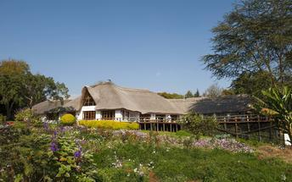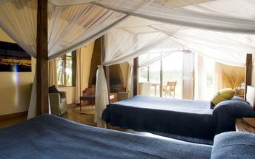

Included
Breakfast, Lunch and Dinner, Specified Activities

DAY 10: NGORONGORO CRATER AND DEPARTURE

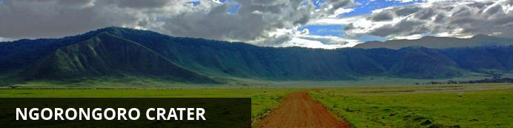
The Ngorongoro Crater is game viewing gone crazy and it is not surprising that with is one of Tanzania’s major tourist drawcards. Within the crater rim a daily wildlife drama is played out as large herds of zebra and wildebeest graze nearby lions, leopards, elephants and black rhinos. Outside of the crater a similar drama continues in a more spread out manner with Masai herdsmen thrown into the mix.

Day Notes
After breakfast, we begin with a sunrise game drive, which is always rewarding to watch the animals eating early in the morning. We have a half day of game drives in and around the Ngorongoro Crater from sunrise to afternoon, exploring hippos pools, looking for lions, and discovering animals around every corner. The goal is to find the black rhino.
After lunch, we begin a long journey back. It will take most of the day to get back to airport. We will stop at some of the abundant craft markets if time permits as we return and then drop you off at the Kilimanjaro International Airport.

Activities
Game drive in Ngorongoro Crater
Return to airport for evening departure (note flights should leave after 20:00)

Included
Breakfast. Lunch and Specified Activities

Estimated 2017 Cash Price: Based on double or triple occupancy (Note if paying by credit card there is a small convenience fee)

$ 3,220 USD Per Person – minimum 4 people
Single Supplement $290 USD if do not wish to share a room

Trip includes:
- All Lodging per itinerary
- All meals per itinerary
- All Park fees, eco-tourism fees and any other government taxes, levies and transit fees.
- English-speaking safari guide
- Private safari transport in 4WD Toyota Land Cruiser or like vehicle
- Maasai Boma Visit and Olduvia Gorge Museum if time available
- Flying Doctors Insurance
- Transfers to/from Kilimanjaro Airport
- Transfers to/from hotel and to/from park entrance/exit gates per itinerary
- Transfer from Arusha to the Red Sweater Project

Trip Excludes:
- Any activities not specified in the itinerary
- Drinks and Laundry
- International air or airport taxes
- Visas
- Travel insurance
- Gratuities to your guide, hotel staff and porters
- All statutory increases beyond our control
- Any items of a personal nature
- Airport transfers outside of the itinerary arrival dates

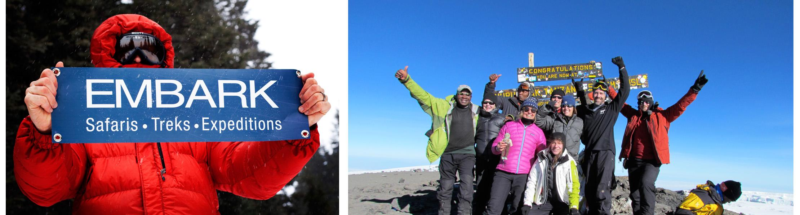

OPTIONAL KILIMANJARO CLIMB - ITINERARY
Kilimanjaro- 8- day Lemosho Route

With fewer than 10 percent of climbers on this trail and the potential to see a variety of wildlife through dense jungle, Lemosho is our favorite way to enter the mountain. At 72 km (almost 45 miles), the longer route allows for more thorough acclimatization and a higher success rate to the summit. The trail passes through five ecosystems, from dense forest and heather up through alpine desert and the glorious summit.
Explore the many variations in landscape and climate on the way up the mountain and spend time capturing breath-taking photos of your surroundings as you move from jungle, to high desert, to snowy terrain on one of the more exciting routes on the mountain, but still manageable by the average adventurer.

Day 01:
Arrive Moshi
Welcome to Moshi- the more quaint, laid-back of the small towns sitting at the base of the famed Mount Kilimanjaro! Upon arrival in Kilimanjaro International airport you will be met by our Tanzanian representatives, who will provide transportation to your hotel. No activities are planned for the day. You are free to explore picturesque downtown Moshi.

Day 02:
Free in Moshi. Overnight in hotel
Morning pre-trip discussion, introduction with trekking guide and in the afternoon you are free to explore some more or do last-minute shopping for the trek.

Day 03: Londorossi Gate to Mti Mkubwa
•Elevation (ft): 7,800ft to 9,000ft
•Distance: 6 km
•Hiking Time:3-4 hours
•Habitat: Rain Forest
Depart Moshi for Londoroosi Gate, which takes about 4 hours, where you will complete entry formalities. With flora and fauna heavier and richer here than on any other route through the thick rainforest, the Lemosho Route cuts through underbrush that is so untouched it at times grows right across the narrow trail. After three to four hours, we'll reach our camp, Mti Mkubwa, which means "Big Tree" in Kiswahili.

Day 04: Mti Mkubwa to Shira Camp 1
•Elevation (ft): 9,000ft to 11,500ft
•Distance: 8 km
•Hiking Time 5-6 hours
•Habitat: Moorland
We continue on the trail leading out of the forest and into a savannah of tall grasses, heather, and volcanic rock draped with lichen beards. As we ascend through the lush rolling hills and cross several streams, we reach the Shira Ridge before dropping gently down to Shira 1 camp. The view of Kibo from across the plateau is amazing.

Day 05: Shira Camp 1 to Moir Hut
•Elevation (ft): 11,500ft to 13,800 ft
•Distance: 9 km
•Hiking Time: 5-7 hours
•Habitat: Moorland
We explore the Shira plateau for a full day. It is a gentle walk east toward Kibo’s glaciered peak, across the plateau, which leads to Shira 2 camp on moorland meadows by a stream. Then we continue to Moir Hut, a little used site on the base of Lent Hills. A variety of walks are available on Lent Hills making this an excellent acclimatization opportunity. Shira is one of the highest plateaus on earth.
Day 06: Moir Hut to Lava Tower to Barranco Camp
•Elevation (ft): 13,800ft to 13,000ft
•Distance: 7 km
•Hiking Time: 4-6 hours
•Habitat: Semi Desert
From the Shira Plateau, we continue to the east up a ridge, passing the junction towards the peak of Kibo. As we continue, our direction changes to the South East towards the Lava Tower, called the "Shark's Tooth." Shortly after the tower, we come to the second junction, which brings us up to the Arrow Glacier at an altitude of 16,000ft. We now continue down to the Barranco Hut at an altitude of 13,000ft. Here we rest, enjoy dinner, and overnight. Although you end the day at the same elevation as when you started, this day is very important for acclimatization and will help your body prepare for summit day.

Day 07: Barranco Camp to Karanga Camp
•Elevation (ft): 13,000ft to 13,100ft
•Distance: 5km
•Hiking Time: 4-5 hours
•Habitat: Alpine Desert
After breakfast, we leave Barranco and continue on a steep ridge passing the Barranco Wall, to the Karanga Valley campsite. This is a short day meant for acclimatization.

Day 08: Karanga Camp to Barafu Camp
•Elevation (ft): 13,100ft to 15,300ft
•Distance: 4 km
•Hiking Time: 4-5 hours
•Habitat: Alpine Desert
After breakfast, we leave Karanga and hit the junction, which connects with the Mweka Trail. We continue up to the Barafu Hut. At this point, you have completed the South Circuit, which offers views of the summit from many different angles. Here we make camp, rest, enjoy dinner, and prepare for the summit day. The two peaks of Mawenzi and Kibo are to be seen from this position.

Day 09: Barafu Camp to Summit to Mweka Hut
•Elevation (ft): 15,300ft to 19,345ft (and down to 10,000ft)
•Distance: 5 km ascent / 12 km descent
•Hiking Time: 7-8 hours ascent / 4-6 hours descent
•Habitat: Arctic
Very early in the morning (midnight to 2am), we continue our way to the summit between the Rebmann and Ratzel glaciers. You head in a northwesterly direction and ascend through heavy scree towards Stella Point on the crater rim. This is the most mentally and physically challenging portion of the trek.
At Stella Point (18,600 ft), you will stop for a short rest and will be rewarded with the most magnificent sunrise you are ever likely to see (weather permitting). From Stella Point, you may encounter snow all they way on your 1-hour ascent to the summit. At Uhuru Peak, you have reached the highest point on Mount Kilimanjaro and the continent of Africa. Faster hikers will see the sunrise from the summit.
From the summit, we now make our descent continuing straight down to the Mweka Hut camp site, stopping at Barafu for lunch. You will want gaiters and trekking poles for the loose gravel going down. Mweka Camp is situated in the upper forest and mist or rain can be expected in the late afternoon. Later in the evening, we enjoy our last dinner on the mountain and a well-earned sleep.

Day 10: Mweka Camp to Gate
•Mweka Camp to Gate
•Elevation (ft): 10,000ft to 5,400ft
•Distance: 10 km
•Hiking Time: 3-4 hours
•Habitat: Rain Forest
After breakfast, we continue the descent down to the Mweka Park Gate to receive your summit certificates. At lower elevations, it can be wet and muddy. Gaiters and trekking poles will help. Shorts and t-shirts will probably be plenty to wear (keep rain gear and warmer clothing handy).
Day 11-13: Visit Red Sweater Project on way to Safari
Day 4-19: Safari in Serengeti, visit Ngorongoro Crater, etc.
Day 20: Departure
Departure for airport for international flight home or add-on safari (if participating in a safari; please make sure to book your international flight home in the evening).
$ 3,195 USD per person
Single Supplement - $250 USD if you do not wish to share a room/tent

Included:
* All international and domestic airport transfers as per the program by private vehicle
* Moshi to Londorossi gate drive by private vehicle
* Londorossi gate to Moshi drive by private vehicle
* Accommodatoin for 3 nights in Moshi and breakfasts while at the hotel
* All park fees
* All meals and accommodations while on climb
* Accommodation, meals, insurance, equipment, transportation and allowances of guide and porter.
* All applicable government taxes

Not included:
* Lunch and dinner in Moshi prior and post-climb.
* Any sightseeing tours in Moshi
* International and domestic airfare
* Bottled drinks (mineral water, any clod drinks, and alcoholic drinks).
* Your travel insurance.
* Expenses of personal nature such as tips for guide, porter and driver, laundry, bar bill, telephone calls etc.
* Liability for expenses against sickness, flight cancellation, road blockage, accidents and other occurrence beyond our control
* Tanzanian visa fee
* Any other expenses not mentioned above.

