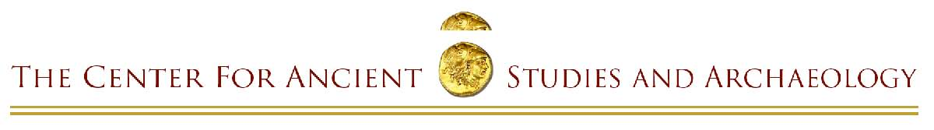
Willamette University • 900 State St. • Salem, OR 97301 • 503-370-6920

Student Internship in Museology at the Hallie Ford Museum of Art Museum Director/Curator Sponsor Recommendation Form
Applications are due by 5:00 pm on March 24, 2017
Applicant’s Name: |  | Date:
Faculty/Professional Sponsor:
Museum Director/Curator:
Phone: | Email:
Please send all materials electronically (as an attached .pdf file) to: rmeyers@willamette.edu

The museum director/curator’s recommendation is an important part of the grant award process. While you may be requested to write more than one such recommendation, there is only one CASA student internship to be awarded. Please answer the following questions, attaching additional pages to this form only if necessary. Your recommendation should be electronically submitted (as an attached .pdf file) to the Centers for Ancient Studies and Archaeology by no later than March 6, 2015.
- Has the applicant discussed with you their interest in this museum internship and their proposed research project? Describe the role of the museum's staff in this internship, should it be funded. Be as specific as possible.
- What specific activities would the applicant be involved with during this 8-week internship? Would this applicant bring any specific skills or expertise to that work?
- In your opinion, is the applicant’s research proposal feasible? Can it be accomplished as indicated, and is the applicant capable of accomplishing the project with appropriate supervision? How would this research project contribute to the museum's goals?

- How is this internship and research project significant to the applicant’s educational development?
5. Do you recommend that we fund this project? Yes No

6. Is there additional information or comments that would help the Grant Committee to make its decision?

