

Emergency Management
Plan for all Hazards

Willamette University

May 31, 2013
Update

TABLE OF CONTENTS

INTRODUCTION 4
PLAN BASICS
INTRODUCTION & POLICY DIRECTION 6
PURPOSE 7
RISK MANAGEMENT POLICY STATEMENT 8
SCOPE 8
POLICIES
Departmental Responsibility 10
Personal Responsibility 11
Leadership 11
RESPONSE
Concept of Operations 11
When to Activate Response Plan 11
Authority to Activate Emergency Operations Center (EOC) 12
University Leadership and Policy Authority 12
Emergency Activiation Levels 12
Level 1 - Critical Incident or Pre-planned Event 12 11
Level 2 - Campus Emergency 13 11
Level 3 - Disaster 13 12
Non-working Hours 15
Emergency Operations Center 15
Notification 15
Means of Notification 16
Assembly and Evacuation 17
Recordkeeping 18
Media Relations 18
Emergency Operations Plan 18 16
What is this plan designed to do? 18
General Explanation of the Plan 19
Description of activity of the Emergency Response Team & Specific Emergency Response 19
Instructions for developing Area Response Plans 20
Some guidance for developing Area Response Plans 21
Area Response Plans
Emergency Response Center (ERC) 22
Student Information Response Center SIRC 23
Vice President for Development and University Relations 24
Vice President for Administrative Services 25
Vice President for Financial Affairs 27
Director of Human Resources 29
Vice President for Information Technology 31
Dean of the Atkinson Graduate School 32
Dean of the College of Law 34
Dean of the College of Liberal Arts 36
Dean of the Graduate School of Education 38
Vice President/Executive Assistant to the President 40
Dean of Campus Life 42
Vice President for Enrollment and Marketing 44
Communications Center 45

TABLE OF CONTENTS (cont.)

Media Preparedness Plan 46
Public Information Functional Procedures 48
Counseling response to campus emergencies and disasters 50
International students and students abroad 52
Bereavement procedures 54
LIST OF ABBREVIATIONS 55
DEFINITIONS 55

INTRODUCTION

In the wake of 9-11, the Federal government established a National Incident Management System (NIMS) for emergency response. NIMS purpose is to enable
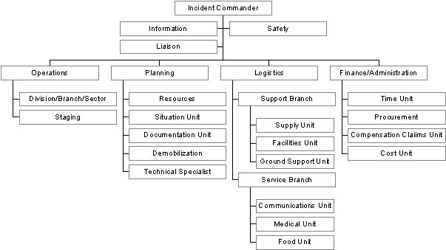
different agencies, organizations, and businesses to work together more effectively to protect life, control incidents, preserve property, and the environment. This document is an “All Hazards Emergency Management Plan” incorporating core concepts, principles, and some terminology from NIMS, using the Incident Command System (ICS), and adapted for use in a higher education environment. ICS is designed to be used for all types, sizes, and complexities of emergencies and selected pre-planned incidents and events. ICS is designed to provide structure and flexibility, meaning it can be scaled up and down depending on the needs of the incident and the direction of the response strategy.

Most activities in this plan become activated when conditions exist where normal operations are interrupted. This type of interruption would require Willamette’s immediate action and coordination of resources and information to save lives, protect property or the environment, and contain or control the incident. The need for heightened coordination may require that an Emergency Operations Center (EOC) be opened to assist in coordinating the response.

In many emergency situations we can expect that Campus Safety would activate the EOC, and/or, notifies an authorized person to activate the EOC. Campus Safety would act as the initial EOC Manager until such time that a more appropriate individual reports for duty. The President, all Deans and Vice-Presidents, the Director of Communications, and the Director of Campus Safety have authority to activate the EOC and act as the initial EOC Manager as the Emergency Response Team (ERT) is assembled.
The ERT coordinates and carries out the response to the incident and supports campus offices and departments in their response. The President continues to serve in the existing university leadership and policy direction role during an emergency. In the Presidents absence, or by request, other members of the President’s Senior Leadership may be asked to serve during the emergency. The Senior Leadership team provides the policy direction that guides the development of strategies and tactics used by the Emergency Response Team. The Emergency Response Team should refer policy decisions to the leadership team. In most circumstances the Senior Leadership Team cedes the operation responsibilities to the ERT.
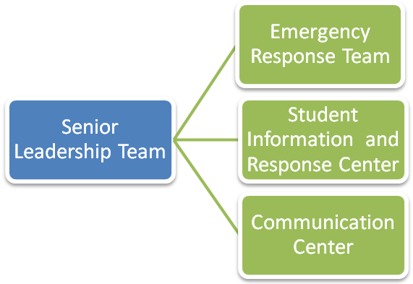
LEVELS OF RESPONSE

Level one is described as a critical incident, which is minor, localized, and quickly contained or resolved. Level one may also be used for a pre-planned incident or event. ICS would be used at the WU office/department level to respond to the incident and/or by other agencies, such as law enforcement and fire. It is unlikely to require coordination by the ERT unless the incident escalates.

Level two is described as a campus emergency, which is a major incident affecting sizable portions of the campus and disrupting orderly operations or educational mission. This requires heightened coordination, so the EOC is likely to be activated to support response and recovery. WU may form a unified command with responding agencies, such as fire and law enforcement.

Level three is described as a disaster affecting the entire campus or surrounding community and may result in little external help. The full EOC would likely be activated. Personnel may be assigned to perform functions that are not part of their normal job functions.

PLAN BASICS

INTRODUCTION & POLICY DIRECTION

Disasters or emergencies can happen suddenly, creating a situation in which the normal support services for the University can become overwhelmed. During crises, the University requires special programs to address the needs of emergency response and recovery management. This All Hazards Emergency Management Plan establishes a standardized, all-hazards system for responding to an incident, emergency or natural disaster affecting the campus. This plan will not be all-inclusive or detail every action, but is intended to provide an organized response to emergency situations.

The Emergency Response Team provides general oversight for the entire emergency planning process and it meets as needed to address ongoing preparedness, mitigation, response, and recovery issues.

Effective emergency and disaster management is the responsibility of both the University and individuals within the Willamette community. The University has an obligation to provide a safe place to work, study, and live while individuals have the responsibility to conduct the affairs of the University safely and to prepare themselves adequately for potential emergencies.

PURPOSE


The All Hazardous Emergency Management Plan is designed to provide the management structure, key responsibilities, and assignments to facilitate the coordination and effective utilization of resources and personnel immediately following rossr incident, emergency or disaster on campus to:

Provide for the safety, health, and welfare of members of the Willamette community and the public:
- Mitigate or contain the incident and its effects
- Preserve property and provide safe occupation of buildings of University owned buildings
- Manage communications and information
- Continue essential services and operations
- Collect and analyze information to support decision-making and incident action plans
- Manage University resources effectively in the emergency response and recovery periods
- Restore general University operations, facilities, and academic programs
- Cooperate with other agencies

RISK MANAGEMENT POLICY STATEMENT
For humanitarian, social, legal, and financial reasons, Willamette University will make every reasonable effort to protect the health and safety of members of its own community and guests of the University from hazards incidental to operations of the University. We strive to protect people and to preserve the resources of the University from harm or losses, thereby enabling the University to educate for lives of thoughtful inquiry, service, leadership, and care. It is the responsibility of all members of our community to conduct themselves in a manner that will not cause personal injury or damage to University facilities.

SCOPE
The Willamette University All Hazards Emergency Management Plan guides preparedness, response and recovery actions. It may be activated during a broad range of emergency incidents. Most all of these incidents could require a response at a Level 1, 2 or 3 level depending on the severity of the situation. The types of incidents include, but not limited to:

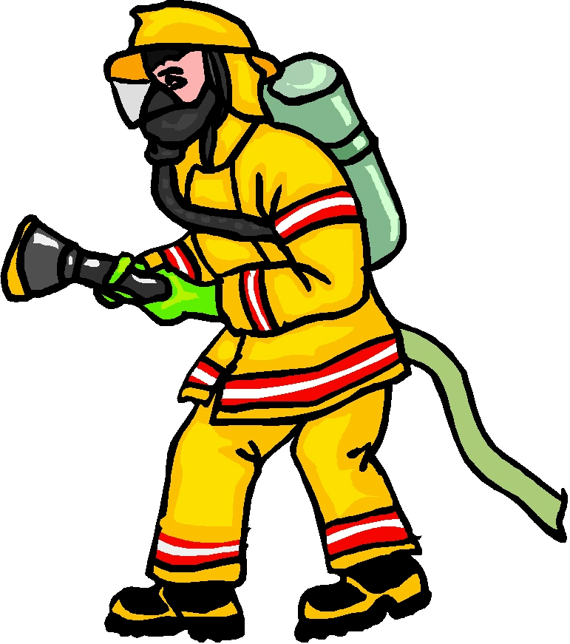

- Earthquakes

- Hazardous Materials Release

- Violent Incidents or Imminent Threats

- Atmospheric Contamination

- Social Unrest

- Terrorism

- Flooding
- International Crisis Affecting Students or Employees

- Utility Disruption

- Mass Casualty Incidents

- Fires and Explosions

- Weather or Storm Incidents

- Traumatic Incidents
- Technological Incidents

- Structural Failures

- Airplane Crash

- Bombs

- Pandemic Illnesses

The All Hazards Emergency Management Plan may also be activated during a community or regional crisis that may affect University personnel or business operations indirectly.

POLICIES
The following policies are intended to guide the University’s preparedness and response efforts. This section is not all inclusive. There may be other policies not stated here that are relevant during an emergency.

Departmental Responsibility

A crisis or emergency can strike anytime or anywhere, and may affect the entire campus community. Planning ahead for emergencies is part of normal business planning and campus life, and all members of the campus community share a responsibility for preparedness. Therefore:
- All administrative and academic units are expected to maintain a departmental Emergency Response and Continuity Plan to protect personnel and programs, and to support campus emergency response and recovery.
- University leaders including Vice Presidents, Deans, Directors, and faculty officers should encourage departmental coordination to develop departmental plans that are consistent with University policies, plans, and procedures.
- All units should maintain contact information for their employees. Each unit is responsible for sharing information and recalling personnel, as necessary.
- Each University organizational unit is responsible for identifying essential personnel – professional or students - before an incident happens.

Personal Responsibility
All employees and students have a personal responsibility for knowing what to do before, during, and after an emergency to protect their safety and work. The Campus Directory (commonly known as the Fusser’s Guide) is also an Emergency Reference Guide and contains several pages of emergency planning and response information.

Leadership
Should the president, a vice president, or dean be unavailable, a back up University leader should be delegated to the leadership responsibility .

RESPONSE

Concept of Operations
This plan is designed as a flexible system in which part or the entire plan may be activated, as appropriate to the incident, emergency, or disaster. It is a management tool that provides an overall organization and general procedures for the management of information, activities, and operations during an emergency.

When to Activate Response Plan
Most actions in this plan are activated when emergency conditions exist in which normal operations are interrupted and immediate action and coordination is required to:
- Save and protect lives
- Containment or Control the Incident
- Prevent damage to the environment, systems and property
- Manage communications and information
- Collect and analyze information
- Manage University resources effectively
- Activate and staff the Emergency Response Center (EOC)
- Restore University operations, facilities, and academic programs
- Cooperate with other agencies to assist others

Authority to Activate Emergency Operations Center (EOC)
During emergencies in which the immediate activation of the EOC is needed, the following individuals have the authority to activate the EOC, and serve as the EOC Manager:
- President
- All Vice-Presidents & Deans
- Director of Communications
- Director of Campus Safety

University Leadership and Policy Authority
The President of the University serves as the leader of the Emergency Leadership & Policy Team and retains authority for such during an emergency. The leader will assign policy team roles to individuals to fulfill the needs of the emergency or disaster. The leader will work closely with the EOC and is responsible for:
- University mission
- University policies
- Academic affairs
- Long-term economic status
- Legal responsibilities
- Representing the University to news media under guidance of PIO
- Maintaining University relations with key constituents, such as faculty, Board of Regents, parents, students, and VIPs
- Death and severe injury notifications

Emergency Activation Levels

Emergency incidents shall be classified according to their severity and potential impact or risk of impact, so that emergency response operations can be calibrated for actual conditions. There are three levels of activation. Generally, the EOC is activated under Levels two and three emergencies, although incident command principles should be applied to all emergency responses as prescribed in unit response plans.

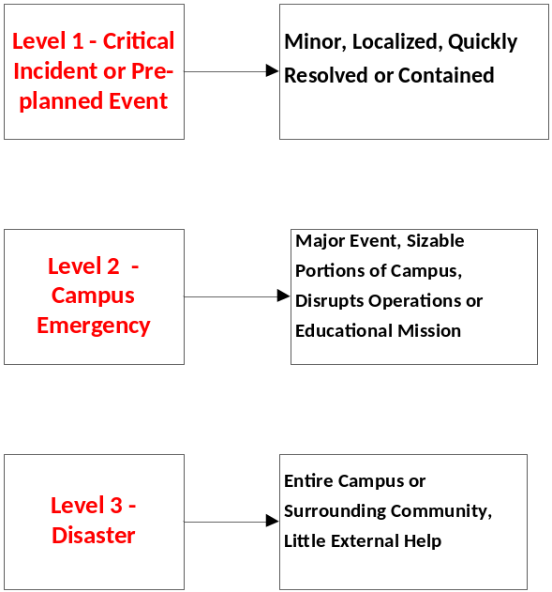

Level 1 - Critical Incident or Pre-planned Event
Minor, Localized, Quickly Resolved or Contained
Level 1 is a minor, localized organization or building incident that is quickly resolved with existing University resources and organizational structures or limited outside help. These incidents happen with relative frequency. A level 1 emergency has little or no effect on personnel or normal operations outside the locally affected area or organization and relies largely on organizational unit response plans.

The process for response at level 1 may involve a unified command of more than one campus department or unit (e.g. Facilities and Campus Safety or Campus Safety and Residence Life) who co-lead or command the response. It may involve simple coordination by the President’s Council.

Level 2 - Campus Emergency
Major Event, Sizable Portions of Campus, Disrupts Operations or Educational Mission
Level 2 is a crisis or major event that disrupts sizable portions of the campus community. Level 2 emergencies may require assistance from external organizations. These events may escalate quickly, and have serious consequences for mission-critical functions and/or life safety. Emergencies happen infrequently.

Unit response plans in many departments are activated and a partial or full EOC is activated to coordinate and support on-scene operations. The EOC Manager is responsible for operational decisions. The President or President’s Senior Leadership designee is responsible for University leadership & policy decisions. The President and EOC Manager work closely together to align response activities with overall University mission.

Level 3 - Disaster
Entire Campus or Surrounding Community, Little External Help
Level 3 represents a disaster that involves the entire campus and/or surrounding community. Disasters happen even less frequently than emergencies.

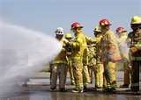
Normal University operations are suspended. The effects of the emergency are wide-ranging and complex. The University may need to be self-sufficient for a period of hours to days or weeks. A timely resolution of disaster conditions requires University-wide cooperation and extensive coordination with external jurisdictions. Willamette will be asked to provide a liaison in another agency’s EOC.

The full EOC is automatically activated. All EOC team members report to the campus EOC. Unit response plans for most or all departments are activated and many personnel are engaged in the University’s emergency response. Personnel may be assigned to perform functions that are not part of their normal job functions.

Non-working Hours
If a disaster occurs outside of regular office hours, the normal organizational structure of the University may not be fully in place. Implementation of the All Hazards Emergency Management Plan will vary depending on available personnel. Individuals assuming responsibility will be those of highest rank available at the time, such as Campus Safety Officers and/or Area Coordinators. These individuals will follow the activation guidelines and task lists presented in this plan, while attempting to notify their superiors of the situation.

Emergency Operations Centers

EOC-Emergency Operations Center
CC-Communications Center
SIRC-Student Information and Resource Center

- The primary EOC is location in the Office of Campus Safety in Doney Hall
- The alternate site is in the 24 Hour Study in Hatfield Library.
- Any other location that facilitates coordination of information and resources.

The nature of an emergency may dictate the locations of these Centers. When applicable the following are the default locations. The designated location for the Emergency Operations Center (EOC) is the Campus Safety Office. If the nature of the emergency makes the Campus Safety office unusable, a number of other suitable locations have been identified. The Communications Center (CC) will be located in an

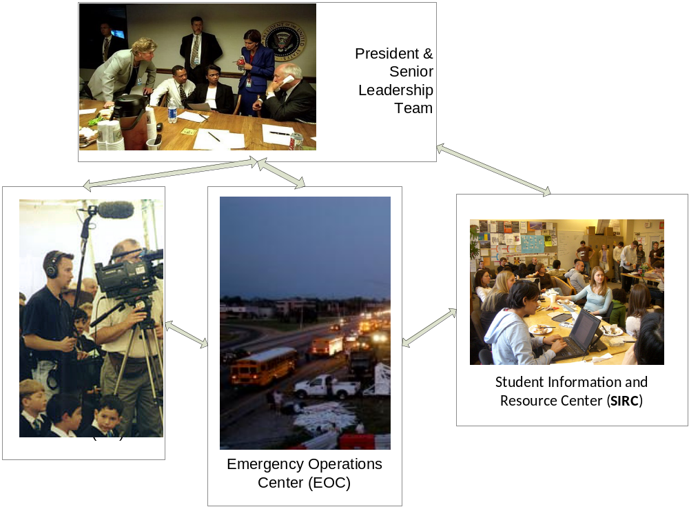

area that best supports the job requirements of the Communications Center, but should provide easy access to the EOC. The Student Information and Resource Center (SIRC) will be located in the Cat Cavern in the University Center, or in the Montag Center if the Cat Cavern is unusable.

Notification

Emergencies may affect only the University, or the University may be affected as part of an event in a wide-spread region. As a result, the event may isolate the University from local emergency services for hours to days.

Emergencies may occur during periods when the University is in session or on break. These eventualities may call for a different mix of personnel in order to effectively respond to the emergency.

In the event of an emergency, it is possible that all personnel, carrying specific responsibilities under the University’s Emergency Operations Plan, will be notified of the emergency and asked to report to their assigned stations no matter when the emergency occurs.

If an individual is unable to carry out her/his responsibilities, another individual from the same administrative area will discharge those responsibilities.

Personnel who are on campus at the time of the emergency, but not assigned responsibilities under the plan, should report to the designated EOC area for assignment or dismissal by the individual responsible for the EOC.

Personnel who are not on campus at the time of the emergency, and who have no assigned responsibilities may be asked to remain away from campus and await word on their role. These individuals are asked not to call campus but to await a telephone call.

Means of Notification
The campus community will be notified about major emergencies in one or more of the following ways:
- Emergency Notification System
Students, faculty, and staff will be notified via cell phone, office, campus e-mail, and/or personal e-mail. All students and employees are automatically signed up for this notification system through the University’s demographic databases.
- Campus Web Site
Home page announcement on www.willamette.edu.
- Emergency Info Line
Recorded message that can be retrieved by calling 503-370-6300.
A special emergency information voice message box (extension 6300) will be used to provide abbreviated reports regarding the status of campus occupants, facilities, and operations. A voice message will be updated frequently to provide current, general information to callers and/or to refer callers to other telephone numbers or the Web site.
The University’s home page also will be used to provide status information regarding campus occupants, facilities and disaster response. If the University’s website is not operating, Pacific Lutheran University will be contacted and has agreed to host our website on their servers. (We will do the same for PLU if their website were inoperable).

Assembly and Evacuation

Each grouping of students and staff will have a designated assembly and census/registration area to which they are to move immediately, in the event of an emergency which may require the evacuation of the buildings(s) they occupy. Buildings will post evacuation plans and evacuation drills will take place for training purposes. Individuals responsible for designating and operating these registration/census areas are indicated in the plan.

Immediately upon arriving at the census/registration area, the individual taking responsibility for that area will take the census of those assigned to the area. Once census/ registration is complete, students and personnel may be directed to another assembly area or dismissed to leave campus. No individual is to return to an area which has been evacuated due to an emergency until official clearance is given by emergency personnel and the president.

As is possible, those leaving campus will be asked to record their destination and telephone numbers where they can be reached. When possible and appropriate, Census/Registration leaders will be given packets containing an up-to-date list of the names of individuals to that area, a pen, flashlight and a distinctive form of identification.

Recordkeeping
Both the Communications Team (CC) and EOC Management Teams will keep a written record of all activities for insurance recovery and as a legal record. Records of damage and field operations will also be gathered.


Media Relations
Only an authorized University spokesperson will meet or talk with the media on behalf of the University during or following an incident, emergency, or disaster. The Public Information Officer (PIO) shall determine who is authorized.

Emergency Operations Plan

What is it Designed to Do?

Willamette’s primary goal in this plan is to maintain or restore orderly operations that support the university mission, respond to the needs of stakeholders and keep our community engaged in the academic endeavor.

Inside this plan is a more complete picture of the breadth of effort required for a response. The ongoing success of this plan is assured when each areas supervisor facilitates and completes emergency response needs in their specific university area of responsibility. By doing this at a department or area level we facilitate a response at a detail level that may not be immediately apparent to the Emergency Response Team.

Each university area is capable of making plans for how they would respond in the event of an emergency. Each area has the responsibility to do so on an ongoing basis. T his effort helps managers and leaders develop a clear understanding of their area capabilities, human resource needs and talents, and necessary resources required to perform their function in an emergency or crisis.

Important considerations

Willamette’s plan is consistent with National Incident Management System (NIMS) and Incident Command System (ICS) organization and procedures.

NIMS and ICS systems enable Willamette to facilitate interoperability with external emergency response agencies and provide an appropriate internal response necessary to support the community. These systems require Willamette to develop specific links to coordinate with City of Salem, State of Oregon, FEMA, Homeland Security and Salem Hospital.

Willamette’s plan may adapt or change during the summer conference and camp season. We experience an influx of individuals who are unfamiliar with the campus and who are supervised by individuals who may be unfamiliar with the campus.

Planning should include an emergency response protocol that addresses that needs of students and employees with disabilities.

General Explanation of the Plan


The Emergency Operations Plan is intended to serve the University as a guide for training and planning preparatory to an emergency, as an outline for action during the emergency, and as a tool for recovery following an emergency. Implicit in the plan is the idea that many emergencies can be avoided through prudent planning and behavior. Not all emergencies can be avoided, however, and the plan is intended to aid the University in responding to these.

The University’s Emergency Preparedness Plan can be activated in one of two ways. An event such as a fire, explosion, building collapse, death of a student or staff member on campus, or riot, would necessitate immediate notification of community emergency personnel. The president would be notified as soon as possible in such cases. In this first instance, the senior administrator on the scene would be responsible for establishing an Emergency Operations Center (EOC) and for putting into place the initial steps of the University’s Emergency Operations Plan.

The second case involves those occasions when the president declares an emergency and invokes the University’s Emergency Operations Plan. Events which could prompt this action would include all of the above and such occurrences as bomb threats, hazard material spills on or near campus, and weather conditions which pose a danger to the campus and its personnel.

Description of activity related to the Emergency Response Team and Specific Emergency Response functions

The following pages contain basic functions for the Emergency Response Team (ERT) and specific response centers in the event of a major incident. Each description is divided into three parts:

- Action which may need to be taken in preparation for an emergency.
- Action which may need to be taken during an emergency or major incident.
- Action which may need to be taken following an emergency.

Although attention has been given, it is likely that these lists, while lengthy, are not complete. In some cases, action which might normally fall within the authority of one area has been inadvertently assigned to another area. Team members should strive for fluidity and flexibility when developing area plans. Please review how your might create back-up and balance of responsibilities during an emergency, within your area and with other areas.

Instructions for developing Area Response Plans

Willamette develops initial phase job descriptions for the senior leaders of the University who will function as an Emergency Response Team. These job descriptions help determine the scope and nature of the activity of the Emergency Response Team for responding to emergency. It also serves to outline activities which would need to take place in the many areas comprising the University in the event of an emergency.

Although we are a small University, the campus is large and complex enough that events can happen in one area without affecting another area. There are some events, however, such as earthquakes, severe weather conditions, flooding and hazardous material spills which can affect the operation and safety of the entire campus.

Events for which response plan action lists are developed in support include the following:

- Student Death, accidental
- Student death, suicide
- Student death, homicide
- Fire: single/multiple structures
- Flood
- Earthquake
- Bomb threat
- Hazmat incident
- Train Derailment
- Airplane Crash
- Weather
- Multiple injury event

We do not expect you to develop a specific emergency response plan for each of these possible events. We desire a framework of desirable actions which would need to occur if your area were called upon to respond to an emergency. The framework should include the activities your area would mobilize to provide assistance in an emergency elsewhere on campus.

Area Response Plans will be included in the University’s overall plan which will, in turn, serve as a guide for the Emergency Response Team in its efforts to coordinate University-wide emergency planning and response.

Some guidance for developing Area Response Plans

In the event the person normally in charge is not available, who is next in charge?


Who is in charge after that?

What are the tasks which would need to be carried out if an emergency were to occur in your area, and who is assigned to carry out each task? List the tasks so that the most important appear first. Keep in mind that, in an extreme emergency, the tasks might need to be carried out by someone outside your area, so be as clear as possible.

A communication plan that outlines the orderly flow of information in and out of your area during an emergency is essential.

What are the tasks which would need to be carried out by personnel in your area if an emergency were to occur somewhere else on campus, and who is assigned to carry out each task? List the tasks so that the most important appear first. Keep in mind that, in an extreme emergency, the tasks might need to be carried out by someone outside your area, so be as clear as possible.

What needs exist in your area for mounting an adequate response to various kinds of emergencies?

Where would (do) you keep these items or information for ready access if you had to evacuate your office quickly?

How often would you need to update or renew the contents of the items or information to keep it operational or current (e.g., monthly, every semester, annually)?

What would you like to say about the role your area would play in the event of an emergency and how would it interconnect with other areas?

What special features of your area would need to be considered or prepared for in the event of an emergency?

Area Response Plan Outlines By Position or Function

Emergency Operations Center (EOC)

Position: Emergency Response Team
Alternate: Listed by Area Response Plan

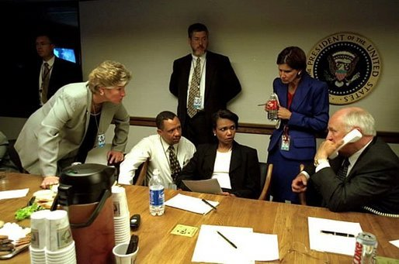
Preparatory Activities

Review applicability of the Emergency Preparedness Plan annually.

Train to assure that all individuals reporting to the EOC are aware of their responsibilities and appropriate actions to take in the event of an emergency.

Assure that functional channels are established between campus emergency personnel and emergency service personnel in the community.

Review and offer suggestions on the president’s proposed budget related to this portion of the emergency response plan to include needed supplies and equipment.

Emergency Activities

Serve as the command and coordination center among on-campus units to campus, local and regional emergency service agencies.

Establish policies and procedures needed to respond to the nature and scope of the emergency as it unfolds.

Establish and maintain communications with responding areas

Follow Up Activities

Review and critique the emergency response performance of the University and revise this document to improve its effectiveness as a planning and execution tool.

Oversee the restoration of University functions, personnel, physical facilities, information systems, and material.

Student Information and Resource Center (SIRC)
Position: Director of Student Activities and Associate Dean
Alternate: Assistant Dean of Camus Life

Preparatory Activities

Develop communication plan that dovetails with emergency response plans for Counseling, Health, and Residence Life

Emergency Activities

Serve as a hub for community communication and support and pass information to the Communications Center and Operations Center as required.


Establish contact with key faculty and academic support administrators to develop plans for resolving or addressing academic issues initiated by the emergency.

Serve as a liaison to communication center and response center for student related needs and resources

Gather information that determines where students are located during the emergency and what resources are necessary to support them in their location. Communicate these needs and secure necessary support.

Assess ongoing needs of students and community and communicate needs to ERT.

Collaborate with Academic Deans on tools and plans for continuing academic progress.

Follow-Up Activities

Position: Vice President for Development and Alumni Relations
Alternate: Director of Alumni Relations

Preparatory Activities

Secure on and off campus storage of electronic alumni data base and development records.

Prepare a resource base that connects to the communication center to names, addresses and methods for communication to alumni and parents.

Create a communication list of important alumni and donors that will require extra attention related to an incident or crisis.

Emergency Activities

Declare a campus emergency and, with information provided by ERT members and local emergency service personnel, designate the scope of the emergency.

Create and facilitate communication through the Communications Center.

Work with finance area and admissions area to communicate to Parents and Alumni significant information.

Follow up activities

Meet with University Relations staff members to evaluate actions taken during the emergency and offer recommendations for revisions to the University’s Emergency Preparedness Plan.

Coordinate fund raising efforts with the president to address financial needs growing out of the emergency.

Propose a budget to the president covering the costs of replacing equipment or supplies lost in the emergency as well as travel for fund-raising purposes.

Review responses during the emergency and develop suggestions for revising the Emergency Operations Plan as needed.

Deactivate systems and procedures when it is determined by the Emergency Response Team that they are no longer needed.
Position: Vice President of Administrative Services
Alternate:

Preparatory Activities

Recommend an annual budget for emergency planning activities, training, and acquisition of materials for use in the event of an emergency.

Designate an individual to serve as liaison with local emergency planning agencies so that cooperation between University emergency response personnel and those of local emergency services is assured.

Designate individuals to take part in Emergency Response training and assures means for incorporating the results of this training into the University’s emergency planning.

Authorize an annual review of the University’s Emergency Preparedness Plan to be certain references to individuals, positions, numbers, and procedures are up to date.

Identify and publish each year a list of suitable fair and foul weather assembly areas for students and employees evacuated from residence halls, classroom and laboratory buildings, administrative offices, and shops and develop and publish the system whereby evacuees will be guided to the assembly areas.

Emergency Activities

Declare a campus emergency and, with information provided by ERT members and local emergency service personnel, designate the scope of the emergency.

Designate and activate the Emergency Operations Center from a list of alternate sites and convene and chair the Emergency Response Team until the President takes control or designates a person to respond on his/her behalf.

In the situation where an emergency destroys, damages or make inhabitable portions of the University’s housing system develop emergency housing facilities.

Develop food service that responds to differing levels of damage to the University’s ability to prepare and serve meals, including alternative food preparation and serving sites during and following the emergency.

Develop a plan for utilizing bedding and other supplies maintained by the University to support temporary student housing, lodging of staff required to stay on campus in the event of an emergency.

Develop with the Physical Plant alternate sites to be utilized as a morgue for the temporary placing of the bodies of those killed in an emergency and draft a plan for activating and overseeing and protecting the operation of this function.
Make available resources in all areas of administrative services to aid the response to the emergency.

Work with ERT members to activate the emergency response systems for which they bear responsibility.

Initiate contact with local emergency service agencies, City, county authorities.

Identify and assign a priority to incidents and response actions, working closely with the ERT and those involved in primary response.

Coordinate response efforts, including campus closure and evacuation, if necessary. When immediate life safety concerns have been addressed, coordinate response to secondary problems.

Deactivate the ERT and Emergency Operations Center.

Follow Up Activities

Convene the ERT to review the response to the emergency and develop revisions to the Emergency Preparedness Plan as required.

Review responses during the emergency and develop suggestions for revising the Emergency Preparedness Plan as needed.

Position: Vice President for Financial Affairs
Alternate: Associate Vice President for Financial Affairs

Preparatory Activities

Develop with the Physical Plant a system for emergency responses including such matters as:
    - Assessing power supply for campus use, including providing emergency power to carry on essential functions
    - Shutting down affected areas related to water, gas, electricity.
    - Complying with OSHA standards
    - Surveying building damage and safety for occupancy
    - Searching damaged facilities
    - Establishing a means for securing potable water
    - Setting up temporary sanitation facilities
    - Setting up and equipping emergency traffic flow, including establishing traffic flow patterns on and around campus.
    - Other steps necessary to preserve life and minimize damage to the physical resources of the University.

Develop with the Director of Human Resources, systems for backing up personnel files and providing access to those files in the event of an emergency.

Create a system that accumulates an account of employees of the University and that tracks which employees are on campus and off campus in the event of an emergency.

Create a plan for the orderly release of nonessential personnel to go home in an emergency.

Create information that aids understanding of how employees will be required to respond in their workplace during an emergency.

Develop with the Associate Vice President for Financial Affairs a system for backing up all necessary University financial records and for carrying on basic business functions during and following an emergency.

For a major or catastrophic event, prepare a financial recovery plan, taking into consideration use of unrestricted, temporarily restricted and permanently restricted funds for approval by the president and the Board of Trustees.

Evaluate and where feasible, secure necessary business interruption insurance, disaster support coverage and restoration services for the university.

Emergency Activities

Declare a campus emergency and, with information provided by ERT members and local emergency service personnel, designate the scope of the emergency.

Develop a system of financial means and support for the ongoing crisis management and disaster recovery.

Manage the operations of the facilities services
Build a communication system for keeping insurance providers involved and in the loop of decision making when applicable.

Prepare information for communication to trustees and stakeholders related to the financial aspects of a crisis response.

Follow up

Review responses during the emergency and develop suggestions for revising the Emergency Preparedness Plan as needed.

Prepare reports and responses to stakeholders on the financial condition of the university if it was affected by the emergency.

Submit to the president a budget adequate to restore academic services (e.g., library, registrar) and information technology services (e.g., network, labs, telecommunications systems) to a functional level on a short-term and long-term basis.

Develop and submit to the Board revisions to the University’s budget required to respond to the damage sustained during the emergency.

Develop and submit to the Board a proposal for interim operation of the University until permanent repair or replacement of physical facilities, infrastructure, and personnel can be made.

Appoint an individual to work with the University attorney and insurance companies in response to litigation growing out of the emergency.

Human Resources

Position: Director of Human Resources
Alternate:

Employee Policy for Leave

An emergency situation at Willamette University will emerge within three possible scenarios, the event occurs during regular work hours; away from regular work hours (between 5:00 P.M. and 7:00 A.M. and on weekends); or, in a period where the university is not in operation (winter holiday).

During regular Hours
Willamette University recognizes the need for employees to ascertain the safety of family and property in the event of a regional disaster or emergency such as an earthquake, flood or severe weather. In the event a regional disaster occurs during regular working hours, the university expects that personnel will try to obtain information about their families. When reasonable, this can occur during work hours and using university resources. Employees will be expected to complete this task quickly and then be available to assist if needed, on campus.

Personnel who are not deemed necessary to provide support and assistance at Willamette, will be dismissed from duties by their supervisor or the individual who has been assigned to provide leadership in their area. In the event of an emergency limited to the Willamette campus or local community, personnel will be asked to remain at their posts until the extent of the emergency is determined. Those not directly involved in the response will be given direction on how they may assist.

After regular work Hours

Should a crisis situation develop during evening or early morning hours, those personnel who are needed will be contacted and asked to report to the campus immediately. In the event of a regional disaster, such as an earthquake, flood or severe weather, essential personnel will be asked to report to campus as quickly as possible.

The same guidelines apply f or any emergency situation which occurs during summer months of closure periods for holidays.

Preparatory Activities-Add
Emergency Activities-Add

Follow-Up Activities

Propose a budget to the president covering the costs of replacing equipment or supplies lost in the emergency.

Review responses during the emergency and develop suggestions for revising the Emergency Operations Plan as needed.

Deactivate systems and procedures when it is determined by the Emergency Response Team that they are no longer needed.

Will staff who choose to take time off and who are dismissed from their responsibilities be required to use leave time accrued, or take leave without pay?

Position: Vice President for Information Technology
Alternate: Director, Network Services

Preparatory Activities

Develop a system for backing up all essential data and for carrying on basic computing functions during and following an emergency, in particular e-mail functions to complement other forms of communication.

Develop a system for maintaining a telephone service during an emergency and for restoring service as promptly as possible once the emergency is past. Develop an action plan that transfers the University’s telephone system to emergency status.

Assure the emergency procedures are in place and available to staff, students, and faculty who utilize various academic and administrative computing sites.

Assure that systems exist for backing up the University’s academic records as a safeguard against loss in an emergency.

Develop with the University Librarian a system for safeguarding library holdings during an emergency, steps needed to preserve holdings damaged during an emergency, and support alternative ways of offering library services in the event of damage to the library building which prevents its occupancy

Assure that systems exist for backing up the University’s financial and other electronic records as a safeguard against loss in an emergency. Develop a plan for recovering necessary hard-copy files to the fullest extent possible.

Emergency Activities

Declare a campus emergency and, with information provided by ERT members and local emergency service personnel, designate the scope of the emergency.

Follow up Activities

Propose a budget to the president covering the costs of replacing equipment or supplies lost in the emergency.

Review responses during the emergency and develop suggestions for revising the Emergency Operations Plan as needed.

Position: Dean of the Atkinson Graduate School
Alternate: Associate Dean

Preparatory Activities

Each dean should have the responsibility of developing plans for their respective areas and that this should be stated in the document under their job descriptions. In this case, the deans would have responsibility for plans related to all personnel (i.e., faculty, administrators and classified staff) and students within their school, but the vice president for academic administration would have responsibility for coordination of these plans.

Develop emergency Preparedness Plans related to personnel, students and programs for their respective schools and coordinate these plans through the vice president for academic administration.

Create an emergency response system for the library services.

Train faculty and other academic personnel in Emergency Response policies and procedures.

Emergency Activities

Declare a campus emergency and, with information provided by ERT members and local emergency service personnel, designate the scope of the emergency.

Determine needs for academic personnel and hire individuals to fill these needs.

Identify needs for instructional supplies and equipment essential to restore the academic program and acquire them through purchase, loan, or donation.

Identify academic facilities which can be occupied safely, and those which need to be closed due to damage.

Identify available classroom and office space that could accept more occupants.

Identify and prioritize needs for reallocation of administrative, research, and classroom space.

Identify as needed space in off-campus academic facilities which can be used until facilities on campus can be restored.

Develop temporary class room and laboratory facilities on campus in manufactured buildings or other suitable structures.

Coordinate the reallocation of space according to pre-established criteria.

Re-establish the University’s system of academic records.

Activate the emergency system for the Library.

Follow-up Activities

Submit to the president a budget adequate to restore academic services (e.g., library, registrar) and information technology services (e.g., network, labs, telecommunications systems) to a functional level on a short-term and long-term basis.

Appoint an individual to work with the University attorney and insurance companies in response to litigation growing out of the emergency.

Review responses during the emergency and develop suggestions for revising the Emergency Preparedness Plan as needed.

Deactivate emergency systems and procedures when it is determined by the Emergency Response team that they are no longer needed.
Position: Dean of the College Law

Alternate: Associate Dean

Preparatory Activities

Each dean should have the responsibility of developing plans for their respective areas and that this should be stated in the document under their job descriptions. In this case, the deans would have responsibility for plans related to all personnel (i.e., faculty, administrators and classified staff) and students within their school, but the vice president for academic administration would have responsibility for coordination of these plans.

Develop emergency Preparedness Plans related to personnel, students and programs for their respective schools and coordinate these plans through the vice president for academic administration.

Create an emergency response system for the library services.

Train faculty and other academic personnel in Emergency Response policies and procedures.

Emergency Activities

Declare a campus emergency and, with information provided by ERT members and local emergency service personnel, designate the scope of the emergency.

Determine needs for academic personnel and hire individuals to fill these needs.

Identify needs for instructional supplies and equipment essential to restore the academic program and acquire them through purchase, loan, or donation.

Identify academic facilities which can be occupied safely, and those which need to be closed due to damage.

Identify available classroom and office space that could accept more occupants.

Identify and prioritize needs for reallocation of administrative, research, and classroom space.

Identify as needed space in off-campus academic facilities which can be used until facilities on campus can be restored.

Develop temporary class room and laboratory facilities on campus in manufactured buildings or other suitable structures.

Coordinate the reallocation of space according to pre-established criteria.

Re-establish the University’s system of academic records.

Activate the emergency system for the Library.

Follow-up Activities

Submit to the president a budget adequate to restore academic services (e.g., library, registrar) and information technology services (e.g., network, labs, telecommunications systems) to a functional level on a short-term and long-term basis.

Appoint an individual to work with the University attorney and insurance companies in response to litigation growing out of the emergency.

Review responses during the emergency and develop suggestions for revising the Emergency Preparedness Plan as needed.

Deactivate emergency systems and procedures when it is determined by the Emergency Response team that they are no longer needed.

Position: Dean of the College of Liberal Arts

Alternate: Associate Dean

Preparatory Activities

Each dean should have the responsibility of developing plans for their respective areas and that this should be stated in the document under their job descriptions. In this case, the deans would have responsibility for plans related to all personnel (i.e., faculty, administrators and classified staff) and students within their school, but the vice president for academic administration would have responsibility for coordination of these plans.

Develop emergency Preparedness Plans related to personnel, students and programs for their respective schools and coordinate these plans through the vice president for academic administration.

Create an emergency response system for the library services.

Train faculty and other academic personnel in Emergency Response policies and procedures.

Emergency Activities

Declare a campus emergency and, with information provided by ERT members and local emergency service personnel, designate the scope of the emergency.

Determine needs for academic personnel and hire individuals to fill these needs.

Identify needs for instructional supplies and equipment essential to restore the academic program and acquire them through purchase, loan, or donation.

Identify academic facilities which can be occupied safely, and those which need to be closed due to damage.

Identify available classroom and office space that could accept more occupants.

Identify and prioritize needs for reallocation of administrative, research, and classroom space.

Identify as needed space in off-campus academic facilities which can be used until facilities on campus can be restored.

Develop temporary class room and laboratory facilities on campus in manufactured buildings or other suitable structures.

Coordinate the reallocation of space according to pre-established criteria.

Re-establish the University’s system of academic records.

Activate the emergency system for the Library.

Follow-up Activities

Submit to the president a budget adequate to restore academic services (e.g., library, registrar) and information technology services (e.g., network, labs, telecommunications systems) to a functional level on a short-term and long-term basis.

Appoint an individual to work with the University attorney and insurance companies in response to litigation growing out of the emergency.

Review responses during the emergency and develop suggestions for revising the Emergency Preparedness Plan as needed.

Deactivate emergency systems and procedures when it is determined by the Emergency Response team that they are no longer needed.

Position: Dean of the Graduate School of Education

Alternate:

Preparatory Activities

Each dean should have the responsibility of developing plans for their respective areas and that this should be stated in the document under their job descriptions. In this case, the deans would have responsibility for plans related to all personnel (i.e., faculty, administrators and classified staff) and students within their school, but the vice president for academic administration would have responsibility for coordination of these plans.

Develop emergency Preparedness Plans related to personnel, students and programs for their respective schools and coordinate these plans through the vice president for academic administration.

Create an emergency response system for the library services.

Train faculty and other academic personnel in Emergency Response policies and procedures.

Emergency Activities

Declare a campus emergency and, with information provided by ERT members and local emergency service personnel, designate the scope of the emergency.

Determine needs for academic personnel and hire individuals to fill these needs.

Identify needs for instructional supplies and equipment essential to restore the academic program and acquire them through purchase, loan, or donation.

Identify academic facilities which can be occupied safely, and those which need to be closed due to damage.

Identify available classroom and office space that could accept more occupants.

Identify and prioritize needs for reallocation of administrative, research, and classroom space.

Identify as needed space in off-campus academic facilities which can be used until facilities on campus can be restored.

Develop temporary class room and laboratory facilities on campus in manufactured buildings or other suitable structures.

Coordinate the reallocation of space according to pre-established criteria.

Re-establish the University’s system of academic records.

Activate the emergency system for the Library.

Follow-up Activities

Submit to the president a budget adequate to restore academic services (e.g., library, registrar) and information technology services (e.g., network, labs, telecommunications systems) to a functional level on a short-term and long-term basis.

Appoint an individual to work with the University attorney and insurance companies in response to litigation growing out of the emergency.

Review responses during the emergency and develop suggestions for revising the Emergency Preparedness Plan as needed.

Deactivate emergency systems and procedures when it is determined by the Emergency Response team that they are no longer needed.

Position: Vice President/Executive Assistant to the President

Alternate: Associate Vice President for Communications

Preparatory Activities

Identify sites suitable for media and information centers in the event of a campus-wide emergency.

Develop procedures to be used for distributing information on and off campus in the event of an emergency, including advising all staff regarding relations with the press during an emergency.

Procure equipment necessary to maintaining the University’s public information function in the event of an emergency.

Develop a system for responding to family inquiries during an emergency.

Determine official spokesperson(s) for the University, prepare them for this assignment, and establish the time and venue for public statements.

Emergency Activities

Declare a campus emergency and, with information provided by ERT members and local emergency service personnel, designate the scope of the emergency.

Immediately establish a communications log and assign a person the task of logging accurately the timing and nature of all actions and communications taken to respond to the emergency.

Provide leadership for all aspects of public and media communications during an emergency.

Establish a media center, in a location different from the Emergency Operations center, where information is distributed and where all media covering a crisis must check in.

Coordinate with the President and all news releases, press conferences, media announcements, etc., regarding the nature of the emergency, how it is being handled, extent of damage, interviews, etc.

With the Dean of Campus Life, Vice President for Development and VP for Enrollment, activate the plan for responding to inquiries from families.

Respond to requests from individuals who wish to volunteer their services during the emergency and direct them to the proper work group.

Keep the President and other officers advised of the nature of inquiries from the media and general public and offer advice on coordinating and releasing information.

Keep off-campus constituencies informed as needed.

Follow Up Activities

Maintain media contacts to keep them informed about the University’s progress in recovering from the emergency.

Maintain systems for consistent communication on campus to keep the campus community informed of progress toward recovering from the emergency.

Propose a budget to the president covering the costs of replacing equipment or supplies lost in the emergency.

Review responses during the emergency and develop suggestions for revising the Emergency Operations Plan as needed.

Deactivate systems and procedures when it is determined by the Emergency Response Team that they are no longer needed.

Position: Dean of Campus Life
Alternate: Assistant Dean of Campus Life

Preparatory Activities

In conjunction with the Vice President/Executive Assistant to the President and the Vice President for Development and Alumni, develop a system for aiding students in responding to family inquiries and develop a method for assuring orderly communication to and from families.

When an emergency or disaster occurs on campus or occurs and affects the campus, the Director of Counseling will be notified and activated immediately.

In the situation where an emergency destroys, damages or make inhabitable portions of the University’s housing system, develop a system for evacuation of residences, registration of evacuees and the safe and orderly transition to designated emergency housing facilities.

Develop systems that allow for the safe and orderly distribution of food and water for students and staff on campus during and following the emergency.

Develop with the Chaplain and Director of Counseling, a system for responding to the spiritual and emotional needs of students and staff during and following an emergency.

Develop a plan for distributing bedding and other supplies available to students and staff that are housed in temporary facilities.

Develop with the Student Health Center a system for establishing triage and first aid sites and the training of personnel to provide emergency first aid. Establish connection and ongoing communication with public health officials, Red Cross, or support agencies where applicable.

Develop with the director of Student Activities and coordinator of the Community Outreach Program a plan for recruiting and organizing volunteers for the student body, faculty and staff to assist with emergency procedures (such as might occur during non-business hours).

Emergency Activities

Declare a campus emergency and, with information provided by ERT members and local emergency service personnel, designate the scope of the emergency.

Issue general instructions to all students and appropriate personnel regarding such matters as: assembly areas to be utilized by those who have been evacuated, locations of key emergency services and protocol and procedures for getting help.

Activate the emergency housing system as needed.

Activate the emergency food service system as needed.

Activate the system to provide spiritual and emotional support as needed.

Activate the system for responding to inquiries from families.

If the situation involves releasing students, obtain travel advisory information for individuals who want to leave the campus and travel home.

Activate triage and first aid system, relating this activity to those of emergency service personnel and such agencies as the American Red Cross.

Activate the system for accessing supplies as needed to provide bedding and other supplies to evacuees.

Follow Up Activities

Deactivate systems and procedures when it is determined by the Emergency Response Team that they are no longer needed.

Review responses during the emergency and to develop suggestions for revising the Emergency Preparedness Plan as needed.

Develop and submit to the president a budget to meet costs incurred during and as a result of the emergency.

Position: Vice President Enrollment and Marketing
Alternate:

Preparatory Activities

Develop with the Vice President/Executive Assistant to the President and the Vice President for Development and Alumni a system for responding to family inquiries during an emergency.

Develop a plan that enables the university to respond appropriately to inquiries from admitted or prospective students who express concern due to an emergency or crisis situation.

With VP for WITS, develop method for access to admissions and financial aid records in the event of an emergency.

Emergency Activities

Declare a campus emergency and, with information provided by ERT members and local emergency service personnel, designate the scope of the emergency.

Activate the plan for responding to inquiries from admitted and prospective students.

Work in and with the Communications Center.

Follow Up Activities

Meet with Enrollment Services staff to review responses during the emergency and to develop suggestions for revision of the Emergency Preparedness Plan.

Develop and submit to the President a budget to meet expenses arising out of the emergency and to keep the University’s admissions program operational.

Review responses during the emergency and develop suggestions for revising the Emergency Preparedness Plan as needed.

Communications Center (CC)

Position: Vice President and Executive Assistant to the President
Alternate: Director of Marketing Communications

In the event of any emergency or crisis situation, whether it is a natural disaster, pandemic, act of terrorism or major accident or chemical spill, it is likely that the Office of the President will be the first point of contact. If the President’s Office is not the first point of contact, any campus recipient of crisis-related information shall first inform the President of the University by contacting the President’s Office.

The Communications Center will:

- Create messages for Websites and emergency voicemail box.
- Recruit staff and train staff related to responding to calls.
- Work with WITS to enable on-campus technology to respond to a large volume of incoming calls.
- Keep emergency information current on the university web site.
- Assign liaisons for communication with local officials (police, fire, health department, hospital) if appropriate.
- Establish personnel and systems of contact and communication with the ERC.
- Establish personnel and systems of contact and communication with the SIC.
- Establish liaison relationships with law enforcement, regional crisis support groups like Red Cross, media, and neighboring stakeholders.
- Respond to media calls.
- Coordinate with the ERCs regarding content, issue emails, media releases, and/or blanket voicemail messages that inform the internal and external communities about important developments or other key information, as technology permits.
- Establish, in advance, if possible, a technology-free communications process, in the event of a lengthy loss of power.

Media Preparedness Plan

Position:
Alternate:

In the event of an emergency at Willamette University, the following procedures will guide the actions of the office of news and publications in serving as media representatives of the University.

At any time an emergency condition exists, the Vice President/Executive Assistant to the President and/or designated representative will be notified immediately and will confer with a designated representative of the Office of Communications. If students are involved, contact with the Dean of Campus Life is imperative. The Communications Officer representative will be informed of the nature of the emergency conditions, the location of the emergency, the time of notification and the status of the emergency condition.

The Communications Office representative will confer with the Vice President/Executive Assistant to the President and/or the Dean of Campus Life and will immediately develop an appropriate response to general inquiries for information about the emergency. Since there is no central telecommunications number on campus that is in operation 24 hours a day, Campus Safety will be the primary contact number as an emergency dispatcher. They should have a copy of the official Willamette response to the emergency, as well as where appropriate administrators can be contacted. The type of statement will be guided by the emergency condition. In general, the statement will provide only factual and specific information, except as restricted by federal and state law, and University policy.

Upon determining the proper response, the Communications Office representative (if necessary) will report to the scene of the emergency and establish liaison with appropriate officials. This representative will counsel, act, or offer to act, as spokesperson to the media and internal audiences as necessary.

All emergency situations will be handled at the lowest administrative level necessary to provide appropriate action. In most cases, the Communications Office representative will be responsible for gathering and disseminating information directly to the news and/or internal media. If severe conditions make it difficult for one person to perform all necessary information functions, the Vice President/Executive Assistant to the President and the Vice President for Development and Alumni and Vice President for Admissions to assign additional Communications office staff to assume responsibilities as directed.

In the event of a major disturbance, disaster, or emergency, the following procedure will be followed:

One or more designated Communications Office and/or appropriate administrative staff members will report directly to the scene of the emergency; one designated News and Publications staff member will report directly to the Communications Center to serve as information production and dissemination coordinator; the Vice President/Executive Assistant to the President will report directly to the ERC to direct the distribution of emergency information to and from the communications center and through the communications center, counsel with appropriate administrators (President, Vice Presidents, Legal Adviser) as well as local police, fire, and media representatives. Upon reaching their assigned locations, all news and publications staff will report by telephone to the Communications Center and establish continuing communications.

Information about the changing nature of the emergency will be coordinated through the Communications Center.

The Communications Center will log the distribution of all news release materials and all inquiries for information on an Emergency Communications Log.

Periodic reports will originate from the Communications Center as necessary until the nature of the emergency condition allows a final report. Communications staff will remain on duty until dismissed by the Vice President or designee.

Public Information Functional Procedures

Responsibilities of the Public Information Coordinator

In a disaster condition, the Public Information Coordinator (PIC) will report to the Disaster Operations Center and be responsible for campus information. The PIC is responsible for the following functions:

Coordination of the rapid dissemination of accurate instructions and information to the campus community.

Responding to media inquiries and calls from the campus community.

Establishment of a Media Release Center for use by representatives of the media.

Determining the need for additional assistance and submitting requests to the Emergency Response Center for additional support.

Information developed and dissemination by the PIC will include, but will not be limited to:

Scope of disaster.
Boundaries of the area in question
Hazards that may exist in the area.
Casualties (if any).
Damages (if any) in dollars.
Number of personnel, equipment, assistance being used in the emergency.
Forecasts of weather which may affect the operations or public safety.
Protective actions required.
Location of emergency medical facilities and decontamination stations.
Sanitary information.
Emergency information for the disabled, sick, etc.

Media Release from the Communication Center

A Media Release Center shall be established and shall function at the direction of the PIC. A Public Information Officer will be in charge of the Media Release Center and it will remain in operation until determined that need of its function and staff no longer exists.

Within the first hour of operation of the Media Release Center, the Public Information Officer will secure liaison with the Disaster Operations Center; assemble and direct needed support staff; secure communication with state agencies which may be involved; establish a public telephone hotline; and activate the Emergency Preparedness Plan.

Resources-available 24 hours/day

The Media Resource Center will include, but shall not be limited to, the following:

Sufficient telephones and lines to accommodate an influx of media inquiries.

    - City and campus phone books (3)
    - Paper, pens, and office materials
    - Photocopier
    - Two staff assistants
    - White board
    - Maps of campus, Salem area, State of Oregon
    - Portable emergency radio for office and field staff
    - FAX machine for sending and receiving information
    - Audio tape recorder and microphone with adapter for feeding actualities
    - Television and radio for monitoring commercial news media broadcasts
    - Computer. etc.

In the event of a disaster or emergency, the following individuals are designated in rank order to serve as a Chief Public Information Officer in charge of the Media Release Center:

Name Title Bus. Phone Home Phone

Counseling Response to Campus Emergencies and Disasters

Position: Director of Counseling
Alternative: Senior Counselor

Preparatory Activities

The Director of Counseling will join with other Campus Life Directors to develop a written plan for a coordinated effort to reach students in the event of an emergency.

Emergency Activities

Counseling work is carried on during emergencies and disasters as part of the work of Student under the general direction of the Dean of Campus Life and as a part of the Student Information and Service Center.

The Director of Counseling Services will meet with the Director of Residence Life and other Student Services personnel during the emergency to implement their plan for reaching affected students.

The Director will provide immediate oversight of counseling activities during emergencies and disasters. In the event of the Director’s absence or disability, the next senior member of the counseling staff on hand will take charge of counseling activities.

The Director will assess the scope of the emergency or disaster and call on counseling staff, other campus personnel, and the community mental health professionals as the Director deems appropriate.

Counselors and others brought in to help handle the emergency or disaster will be deployed and supervised by the Director of Counseling Services.

Those providing counseling services will meet with the Director at least daily to discuss the status and level or distress among those affected by the emergency or disaster, to identify individuals whose response to events is especially tenuous, and to organize efforts for the next day.

The Director, working with the staff, will decide whether to set up special counseling posts in a location more strategically appropriate to the event than the counseling offices.

The Director, working with the counseling staff, will determine when to end the services of off-campus providers and will design the kinds of services needed to provide continued care for individuals.

Follow-Up Activities

The Director will prepare a written report for the Dean of Campus Life summarizing consulting services provided during the emergency or disaster and offering suggestions on the changes needed in the University’s emergency system.

International Students and Study Abroad

What may constitute an emergency?
Absent without explanation
Disappeared, lost, unaccounted for
International crises
Death
Suicide
Medical issues
Accident
Illness
Surgery
Significant psychological problems
Problems at home
Legal problems
Accused of crime
Victim of crime
Government policies or inquiries

Should be the campus crisis team be convened?
.
How to tell students what they need to do?
Face to face communication is best; telephone if necessary. Follow-up every conversation with instructions in writing (creates a paper trail – and realizes students do not always understand what is spoken or written).

Consider who should be contacted, why, who needs information now?
Possibilities include:
President
Deans
Campus Safety
International Program Office
Study Abroad Directors
Academic Advisors
Public Information Officer
Local Law Enforcement Officials
Students Involved
Parents of Students
Host family
Consulate
Local Newspapers

For each notification – who should be the spokesperson for the University? If people in distant locations need to be notified, should contact be made by ?

Phone call from appropriate person at Willamette
Clergy at distant site
Police at distant site
An alum at distant site

What documentation needs to be developed?

What are insurance and liability issues to be addressed?

What generic handouts can be created to give to students to prevent emergencies from arising?

Can we establish emergency telephone numbers all students should be given?
Campus switchboard
Campus Safety
Deans

Can we develop a wallet sized emergency card for all travelers abroad, and foreign students here?

Willamette University Bereavement Procedures

Recognizing that each circumstance differs and that one can not legislate how grief or bereavement will, in fact, occur the following is set out as a guideline for manners in which the University might consider responding to deaths that affect its students:

If an enrolled student dies:

The Dean of Campus Life will notify the Counseling office.
The Dean of Campus Life will notify the President of the University.
The Dean of Campus Life will notify the Chaplain.
The Chaplain will send a condolence note to the student’s family as deemed most appropriate at the time, and after discussion with the family.
The Chaplain will arrange for a scholarship donation or library book purchase to be made in the student’s name, flowers to be sent to the funeral, or a fruit basket to be sent to the family if possible.
The Dean’s office will arrange for someone (current staff, trustee, alum) to represent the University at the funeral.
If a student lives on campus, the Dean of Campus Life will notify the Director of Residence Life.

If the spouse of a student or the parent of a student dies:

The Dean of Campus Life will notify the Counseling Office.
The Dean of Campus Life will notify the President.
The Dean of Campus Life will notify appropriate professors and advisors.
The Dean of Campus Life will notify the Chaplain.
The Chaplain will send a condolence note to the students’ family as deemed most appropriate at the time and after discussion with the family.
The Chaplain will arrange for a scholarship donation or library book purchase to be made in the student’s name, flowers to be sent to the funeral, or a fruit basket to be sent to the family if possible.
The Dean’s office will arrange for someone (current staff, trustee, alum) to represent the University at the funeral.

The Chaplain will send a condolence note to the student if possible, the Dean’s office will arrange for someone (current staff, trustee, alum) to represent the University at the funeral.

LIST OF ABBREVIATIONS

CO Communications Officer
EOC Emergency Operations Center
IAP Incident Action Plan
ICS Incident Command System
JIC Joint Information Center
NIMS National Incident Management System

DEFINITIONS
Command Staff. NIMS lingo that includes the Public Information Officer, Safety Officer, and Liaison Officer who report directly to the EOC Manager.
Critical Incident. Level 1 emergency response. Minor, localized, quickly resolved or contained or a pre-planned event or incident.
Campus Emergency. Level 2 emergency response. Major event, sizable portions of campus. Disrupts orderly operations or educational mission.
Disaster. Level 3 emergency response. Entire campus or surrounding community. Little external help.
EOC Management Team. The EOC Manager and appropriate (based on incident needs) In NIMS lingo….Command and General Staff.
Financial Affairs. The Section responsible for all incident costs and financial considerations.
Incident Action Plan (IAP). An oral or written plan containing general objectives reflecting the overall strategy for managing an incident for an operational period. May include operational resources and assignments, safety information, and other information for managing the incident.
Incident Command System (ICS). A standardized on-scene emergency management construct. ICS is the combination of facilities, equipment, personnel, procedures, and communications operating within a common organizational structure, designed to aid in the management of resources during incidents. It is applicable to all types and sizes of incidents.
Incident Objectives. Statements of guidance and direction necessary for the selection of appropriate strategy(ies), and the tactical direction of resources. Incident objectives must be measurable and achievable, yet flexible enough to allow for strategic and tactical alternatives.
Liaison Officer. A member of the Command Staff responsible for coordinating with representatives form cooperating and assisting agencies.
Mission-critical Functions. Activity, device, service, or system whose failure or disruption in normal business hours will result in the failure of business operations. For example, in higher education failure of the enterprise-wide computer system (at WU this is Datatel ) would lead to inability for WU to conduct business.
National Incident Management System (NIMS). A system mandated by HSPD-5 (Homeland Security Presidential Directive) that provides a consistent nationwide approach for Federal, State, local, and tribal governments; the private sector; and non-governmental organizations to work effectively and efficiently together to prepare for, respond to, and recover from domestic incidents, regardless of cause, size, or complexity. NIMS includes a core set of concepts, principles, and terminology listed as follow:
- Multi-agency coordination systems
- Training
- Identification and management of resources
- Qualification and certification
- Collection, tracking, and reporting of incident information and incident resources
Operations Section. The Section responsible for all tactical operations at the incident.
Planning Section. Responsible for the collection, evaluation, and dissemination of information related to the incident, and for the preparation and documentation of Incident Action Plans. This section maintains information on the current and forecasted situation, and on the status of resources assigned to the incident.
Public Information Officer. A member of the Command Staff responsible for interfacing with the public and media or with other agencies with incident-related information requirements.
Response Centers. Departments that are involved in field response operations, such as Campus Safety, Facilities Management, Scheduling, Events and Conferences, Residence Life
Strategy. The general direction selected to accomplish incident objectives set by the EOC Manager.
Tactics. Deploying and directing resources on an incident to accomplish incident strategy and objectives.
Unified Command. An application of Incident Command System used when there is more than one agency or WU department with incident jurisdiction or responsibility. Departments or agencies work together with a designated Unified Command to establish a common set of objectives and strategies and a single Incident Action Plan.
University Leadership & Policy Team. The President and members of the President’s Administrative staff who form the executive leadership of the University. The President continues to carry out executive leadership of the university during times of crisis and is responsible for policy decisions as it relates to the emergency response operation. Other members of the President’s Council may serve in the President’s absence or at his request in this capacity.

