Professional Bio

& LinkedIn Connection

Due: July 7, 2017
Questions? mbacareer@willamette.edu
A professional biography is a condensed statement that highlights your experience, interests, and goals. You will likely be asked to produce a bio or professional summary throughout your career for a variety of uses. The purpose of this professional bio is to inform and engage your audience on LinkedIn.

This assignment is part of the Willamette University MBA Writing Program. When you submit the assignment, a writing coach will review your work and provide feedback electronically. After receiving your feedback you will have an opportunity to revise your bio and post it to the “Summary” section of your LinkedIn profile.

If you don’t yet have a LinkedIn profile, now is the time to get one started! Begin creating your account here: https://www.linkedin.com then, follow the steps below to write your professional bio. If you are new to LinkedIn or if your current profile needs some refreshing, you may want to use this LinkedIn Profile Checklist to get started.

Step 1: Read
- Three Steps to Writing the Perfect LinkedIn Summary (Forbes, 2014) https://www.forbes.com/sites/williamarruda/2014/09/07/three-steps-to-writing-the-perfect-linkedin-summary/#5fbf30e5fbf3

Step 2: Review the LinkedIn bios (summaries) of others.
- Note what works and what doesn’t. How are they engaging their audience? Pay attention to the formality; bios writing in 1st person can seem more personable, while those written in 3rd person come across more formal. Here are some examples:
  - https://careers.sewanee.edu/media/careers/toolbox/LinkedIn_Summary_Samples.docx.pdf
  - https://business.linkedin.com/talent-solutions/blog/linkedin-best-practices/2016/7-linkedin-profile-summaries-that-we-love-and-how-to-boost-your-own
  - https://www.themuse.com/advice/5-templates-thatll-make-writing-the-perfect-linkedin-summary-a-breeze

Step 2: Set the scene
- Consider your target audience. Who will be reading your bio? Recruiters, friends, colleagues, former colleagues? What is it that you want them to know about you?
Step 3: Gather content
- What are your accomplishments, values, passions? What is it that differentiates you from others?
Step 4: Write
- In General: Make sure to include an engaging opening and tell an engaging story that showcases your skills/experience. Consider using the formats and writing structure that you observed in step 2.
- Or, consider using the following sequence:
Paragraph 1: Description of job, level, expertise, years of experience
Paragraph 2: Current/recent responsibilities, accomplishments, overview of earlier experience, and awards/honors
Paragraph 3: Preferred work style (collaborative, project-based, remote, etc.), character traits (personable, conscientious, creative, results-driven, etc.)
Paragraph 4: Education or other job qualifications
Paragraph 5: Call to action – interest in exploring opportunities, contact information

Submitting Your Bio & LinkedIn Connection (3 PARTS)

Part 1: Submit Your Bio on WISE
When you submit your bio, it will be reviewed by a professional writing coach and returned to you via WISE with feedback within 3 weeks. You are strongly encouraged to revise your bio using the feedback from your coach and update LinkedIn accordingly. Steps to submit assignment on WISE:
- Login to WISE here: https://wise.willamette.edu/portal/
- Select the Writing Course GSM WRITE 01 17/FA from the top navigation
- Detailed screenshots and instructions are listed at the end of this document. Refer to those to submit your assignment for the “Professional Bio”

Part 2: Paste your Bio Text in the Summary Section of Your LinkedIn Profile
- If you do not yet have a LinkedIn profile, be sure to create one here: https://www.linkedin.com/feed/
- Click on your profile picture in the top left of the screen
- Select “view profile”
- Select the “pencil icon” to edit your profile
- In the editor, scroll down to the “summary” section and paste or type the text of your bio into this section
- Select “Save”

Part 3: Connect with Beth and Sarah on LinkedIn to indicate that you have completed the assignment.
- If you do not yet have a LinkedIn profile, be sure to create one here: https://www.linkedin.com/feed/
- Once logged in to LinkedIn, search for “Beth Ursin” and “Sarah Kutten” or use the links below.
- Beth - https://www.linkedin.com/in/eursin/
- Sarah - https://www.linkedin.com/in/sarahkutten/
- Select the “Connect” button to connect with us.

WISE Resources

How do I submit an assignment?

Go to Assignments.
Select the Assignments tool from the Tool Menu in your site.

Click on the title of the assignment.
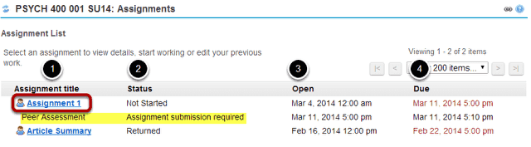
Zoom
You will a list of all assignments in the site. The following information will be displayed for each assignment.
- Assignment title, or name of the assignment.
- Status (i.e. Not Started, Assignment submission required, Returned, etc.).
- Open date when the assignment becomes available to students.
- Due date, or deadline to turn in the assignment.
Select the assignment you want to submit by clicking on the title of the assignment in the list.
Note: If your assignment has a peer review component, the Peer Assessment for the assignment will appear immediately beneath the assignment title in the list.

Or, click the direct link to the assignment in Lessons.
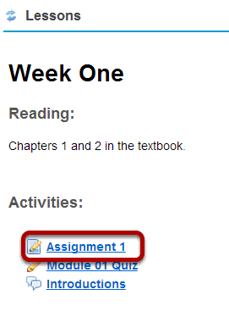
If your instructor has included a link to the assignment in the Lessons tool, you may also access it from this location within the course content.

Or, click the direct link to the assignment from Announcements.
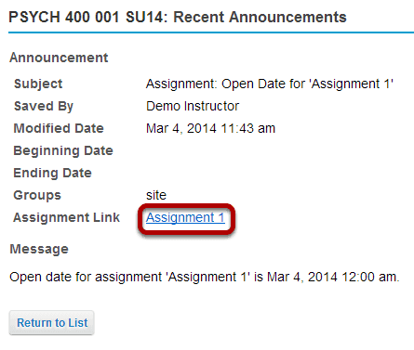
If your instructor has posted an announcement about the assignment open date, you may also access it from the assignment link in the Announcement tool.

Or, click the direct link to the assignment from Schedule/Calendar.
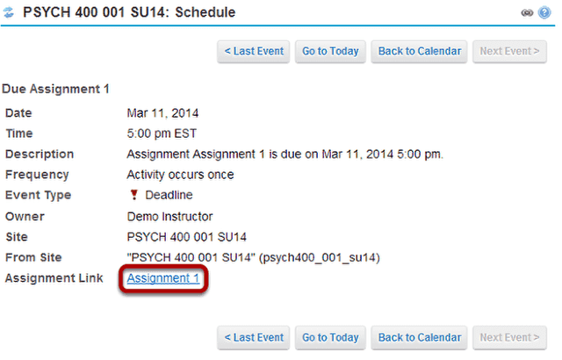
Zoom
If your instructor has included a calendar post about the assignment deadline, you may also access it from the assignment link in the Schedule/Calendar tool.

Enter and/or attach your assignment.
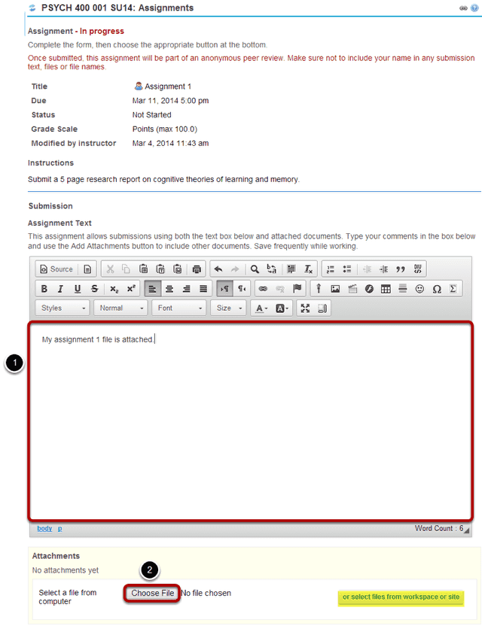
Zoom
Depending on the assignment settings, you may be allowed to enter your submission in-line and/or attach a file or files.
- Enter your submission text into the Assignment Text area using the Rich Text Editor.
- Under Attachments, click the Choose File button to browse for an select a file to upload from your computer. (Alternately, you may also click the or select files from workspace or site button to select a file you have already uploaded.)

View attached file.
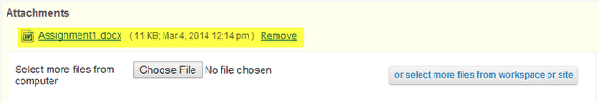
Zoom
Once you have attached your file, the name of the file, as well as the file size and upload time stamp will be displayed under Attachments.
Tip: You may click Remove to remove the attachment if you selected the wrong file.

Submit your assignment.
Zoom
When you are ready to turn in your assignment, click the Submit button to complete your assignment submission.
Tip: If you are not yet ready to submit, you may click Preview to preview the submission, or Save Draft to save your submission and submit it later. Click Cancel to exit the assignment without saving or submitting.

Submission confirmation.
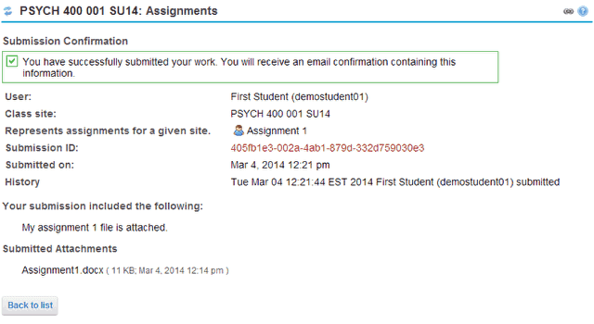
Zoom
Once you have submitted your assignment, you will receive a confirmation message on screen. In addition, if you have opted to receive email notifications, you will also receive an email confirmation of your submission.

How do I view my assignment feedback?
Once your instructor has graded your assignment, you can view the feedback on your work in the Assignments tool.

Go to Assignments.
Select the Assignments tool from the Tool Menu in your site.

Click on an assignment.
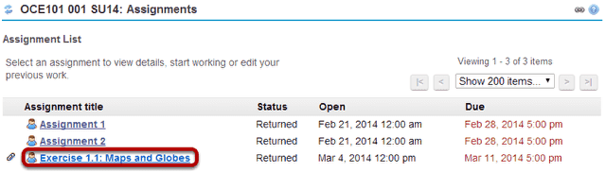
Zoom
Click on the title of an assignment to view the feedback for that item.
Note: Assignments which display Returned in the Status column have been graded and the feedback released for student viewing.

View assignment and feedback.
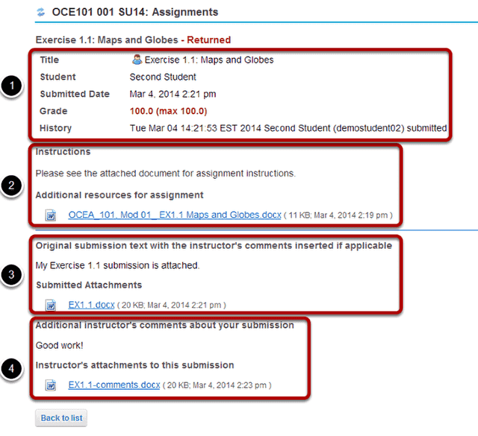
Zoom
Your assignment and feedback will be displayed.
- The title, student name, submission date, and grade appear at the top.
- The original assignment instructions and attachments appear below the submission and grade information.
- Your submission and/or attached files display below the assignment instructions.
- Instructor comments and/or attached files appear at the bottom.
Note: If your assignment had a peer assessment component, and your instructor has allowed students to see peer reviews of their own work, you will also see peer reviewer comments on the feedback screen.

