Brain Science
In a recent study on students’ perceptions of how they learn best, they overwhelmingly learned better by spacing out a variety of learning techniques — yet when asked which approach had benefited them more, students overwhelmingly said cramming. “Our intuitions are not a good guide for how to optimize learning, nor are standard practices from years past,” says Bjork. “It’s the research that should be the guide, but it’s a tough battle to introduce and make some of those changes.” (Jaffe, E. (2008). Observer Vol. 21, No.10 November 2008)
Learning: The importance of daily studying in long-term recall capabilities
The more we repeat this information, the stronger the neural path becomes, and the easier it is to retrieve the information learned
However, if you do not reinforce the neural pathways by repeating or reviewing what you learned the pathways die. It’s as if you never learned the information
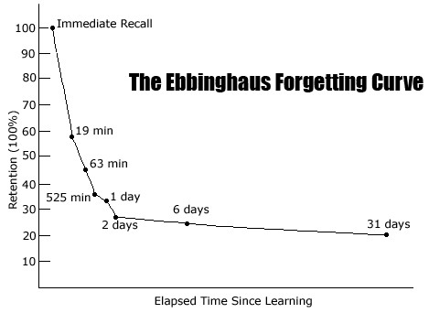
When we encounter new information our brains interpret that information by sending electric signals through neurons

Stress and Anxiety: Avoid excessive stress or anxiety when studying or taking tests
Results of Fight of Flight:

The hypothalamus
is stimulated by
a release of
adrenaline or
cortisol which makes your body
enter a ‘fight or
flight’ response
state
Rational thought in your frontal lobe is blocked and routed to the cerebellum- focus changes to quick physical responses
Impossible to engage in rational thinking or memory recall until you are able to physically relax
Focusing on being calm will cause the adrenaline to subside and your neurons will be able to re-engage your frontal cortex so you can think clearly
Experiencing
stress, internal or
external, causes an
immediate reaction in our
bodies

Physical Conditions to Promote Optimal Brain Power: You really are what you eat
Environment- if it’s too hot or too cold, your brain does not function properly. Your brain also thrives on challenge, continue to explore and experience new things often for a more powerful and engaged mind
Inputs- you need healthy foods, rich in omega fatty acids, vitamins, and minerals to promote healthy neural connections. Additionally, water and oxygen are the most important inputs in a clear thought process
Movement- exercise increases oxygen levels in your blood, which increases your brain’s ability to work efficiently. It is imperative to take study breaks to move in order to keep your neurons firing quickly
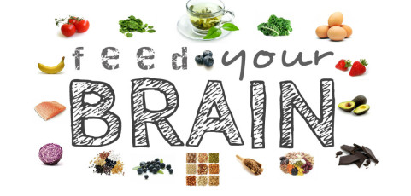
Our brains re-create themselves every second of every day. It is the most complicated and powerful muscle we possess as humans. Do not limit yourself and you will be capable of great things

