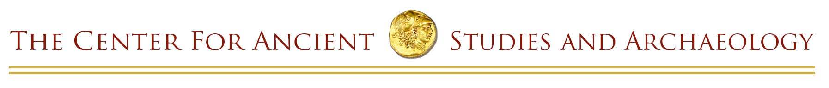
Willamette University • 900 State St. • Salem, OR 97301 • 503-370-6620

Student Internship in Museology at
the Hallie Ford Museum of Art Faculty Sponsor Recommendation Form
Applications are due by 5:00 pm on March 24, 2017
Please send all materials electronically (as an attached .pdf file) to: rmeyers@willamette.edu
Applicant’s Name: |  | Date:
Faculty/Professional Sponsor:
Phone: | Email:
The sponsor’s recommendation is an important part of the grant award process. While you may be requested to write more than one such recommendation, there is only one CASA student internship to be awarded. Please answer the following questions, attaching additional pages to this form only if necessary. Your recommendation should be electronically submitted (as an attached .pdf file) to the Centers for Academic Excellence by no later than March 24, 2017.
- How long, and in what capacity, have you known the applicant?
- How would you describe the applicant’s academic and intellectual abilities? How would you describe his/her work ethic?
- How is this project significant to the applicant’s educational development?
- Do you recommend that we fund this project? Yes No
- In your opinion, is the applicant’s proposal feasible? Can it be accomplished as indicated, and is the applicant capable of accomplishing the project with appropriate supervision?
- The Grant Committee will evaluate the proposal, in part, on whether the sponsor’s background is appropriate to the project. What aspects of your academic background or experience will assist the student in his or her proposed research?
- Describe your role as sponsor, should the project be funded. Be as specific as possible.
- Is there additional information or comments that would help the Grant Committee to make its decision?

